**Dynamic UI Framework**

Contents:

1. Introduction

1.1 About This Document

1.1.1 Scope of this document

1. Component Design

2.1 Component design diagram

2.1.1 Overall Workflow

2.1.2 Low Level Design

1. Technology & Frameworks Used
2. Solution Approach

1. Introduction

1.1 About this document

1.1.1 Scope & Purpose of this document

A Dynamic UI is a user interface that can adapt according to user input. A framework is the basic structure underlying a system. This Dynamic UI Framework will focus on creating a hassle-free interface for the user and will store most of the html data in a JSON format in the client machine in order to reduce time and ultimately, improve user experience. The purpose of this document is to provide a blueprint for developers who want to create a reusable component for a user interface that can be integrated into any application of the same tech stack.

2. Component Design

Component Design Diagram

Dynamic UI Framework

Simple/Advanced Search ,Grid

Generic Popup

Consumer

This is an implementation of a sample template featuring a Dynamic UI where the client will interact with the UI while being able to change/view information available by making use of their configuration file.

2.1.1 Overall Workflow

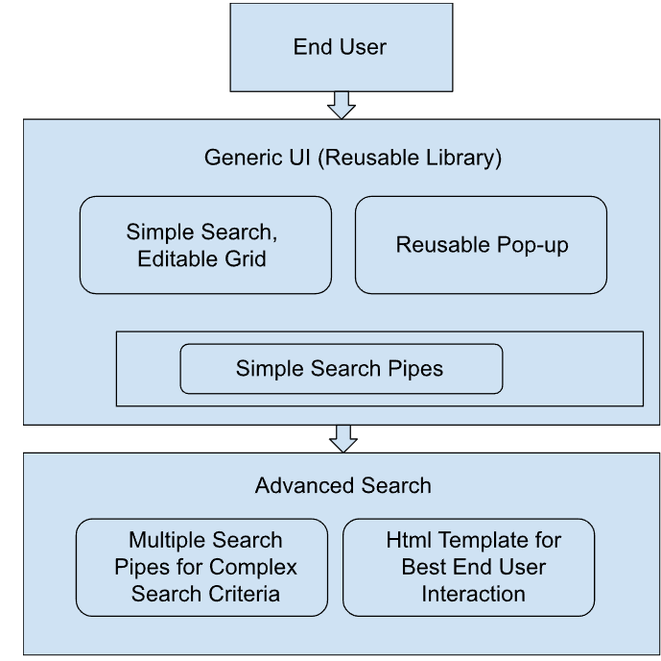

2.1.2 Low level Design

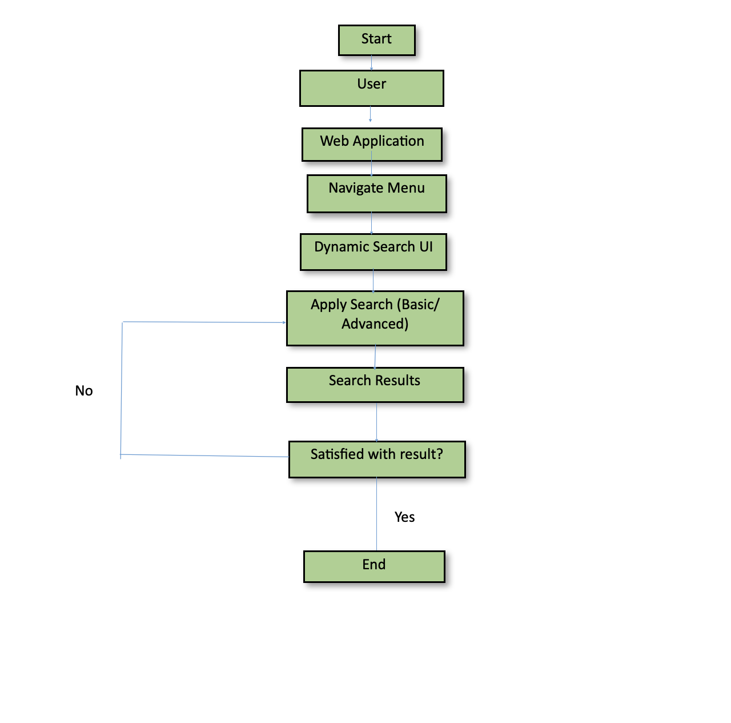

3 Technology & Frameworks used  
This below lists down the details on technology and framework used for development of the UI.

* 1. Angular 15.2.4
  2. Node 19.7.0
  3. AG-Grid-Angular

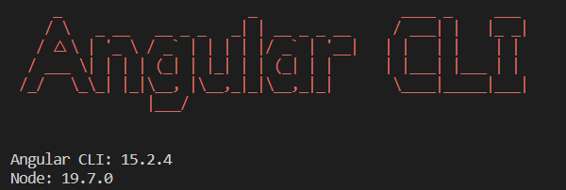

4 Solution Approach

This is a description of how we see clients using our framework.

We have multiple libraries that can be reused for many Use-Cases.

These include:

* Grid Library
* Generic Pop-Up Library
* Logger Library
* Simple/ Advanced Search which is present in Grid Library